Kartik Yadav

MBA(BA)

IIFT Delhi

**Report**

Analytical Dashboard on financial instruments including stocks, indices and cryptocurrencies.

**Introduction:**

This R Shiny dashboard is designed to display key financial indices, stocks, cryptocurrencies and more. It serves as a dynamic and interactive tool for information on financial markets and data analysis. It leverages real time data from Yahoo finance to present market information for traders, investors, and finance enthusiasts to keep track of market trends and make informed decisions.

**Key Features:**

**Diverse Market Data:** Covers a range of financial instruments including stocks, indices, and cryptocurrencies.

**Real-Time Updates:** Integrates data from Yahoo Finance to ensure current and relevant market insights.

**Interactive Interface:** Built using Shiny, the app offers an engaging and user-friendly experience.

**Visualisation:** Creating tables, graphs, interactive buttons and search bars to select the stock, index or cryptocurrency to view.

**Analysis:**

Home Tab:

Indices and Watchlist: Past year trends of indices and closing stock details.

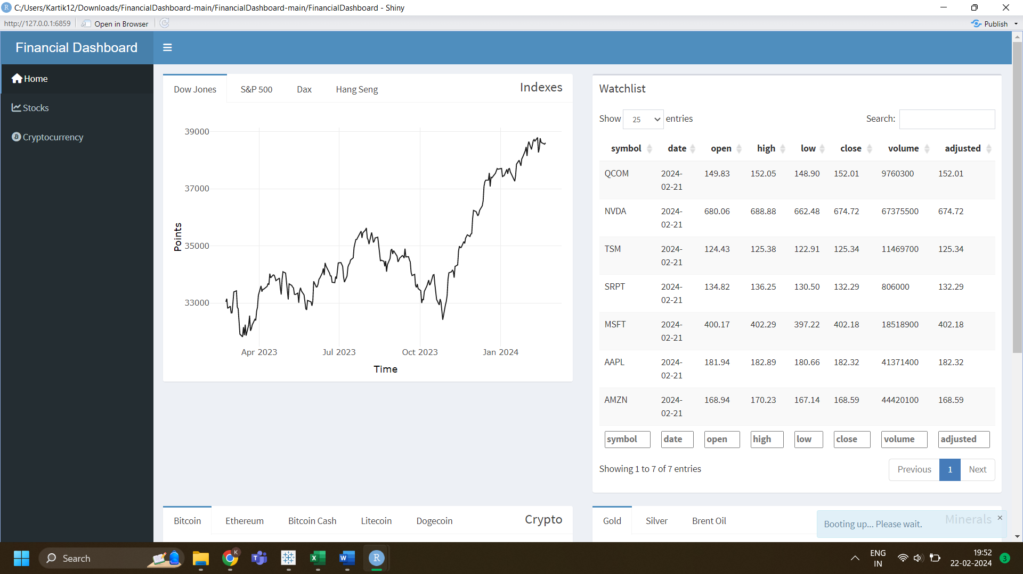

Crypto and Minerals: Past year trends of cryptocurrencies and minerals.

Stocks Tab:

Last closing of major indices, search bar to select the stock, radio buttons to choose the time frame. Line graph showing the closing price trends of the selected stocks and their monthly returns.

Cryptocurrency tab: Line chart and candlestick chart showing the trend of different cryptocurrencies’ values and closing price for the past 2 quarters.

